VEHICLE MANAGEMENT SYSTEM USING SALESFORCE

1. INTRODUCTION
   1. Overview

Vehicle Management System is a windows application written for 32-bit Windows operating systems which focused in the area of adding, editing and deleting the passengers, staff and the bus routes. In this software a person can be register as a user and he can manage the bus routes and the staff, passengers' details. The Vehicle Management System (VMS) is an application for the Automotive industry. It supports, in the area of Sales & Services, the business processes that you require as vehicle importer when dealing with your original equipment manufacturers (OEMs) and your dealers in new and used vehicle sales .

To assist in the tracking ofvehicles operation and the planning of maintenance that is important to avoid any damage/unexpected problem that might occur in the future that may cause hindrance to the operation and/or risking the safety of the drivers and passengers. An in-vehicle monitoring system (IVMS) describes electronic device that is used to track, assess and report on vehicle activity any which in turnreflects on the driver's behaviour. You can ensure that your company meets regulatory standards and fullcompliance through a quality management system.

These standards must be carefully followed which a quality management system can help you achieve. Performance and product issues can be discouraging to customers and a detriment to your brand. A good EV charging management system will monitor the chargingprocess of all the vehicles in the system. It will also monitor real-time energy production, load balancing, local energy consumption, and electrical infrastructure capabilities.

**The characteristics of management are:**

* Goal-oriented.
* Pervasive.
* Multi-dimensional.
* Continuous process.
* Group activity.
* Dynamic function.
* Intangible force.

1.2 Purpose

Fleet (vehicle) management can include a range of functions, such as vehicle leasing and financing, vehicle maintenance, licensing and compliance, supply chain management, accident management and subrogation, vehicle telematics (tracking and diagnostics), driver management, speed management, fuel management, health .

Vehicle management system is an automated software for the transportation industry or an organization which owns a large number of vehicle & managing fleets. A DMS is a piece of software created to help car dealerships handle daily tasks like sales, finance, service, and parts. It offers reporting and analytical tools and aids dealerships in managing their inventory, clients, and sales processes.  
 A vehicle tracking system is a software system used by transport companies to monitor the location of trucks, trailers and other vehicles. The software is connected to the vehicles via GPS, giving companies real-time insight into the geographic position of their vehicles.

A transportation management system (TMS) is a logistics platform that uses technology to help businesses plan, execute, and optimize the physical movement of goods, both incoming and outgoing, and making sure the shipment is compliant, proper documentation is available.

Back to the basics: dealer management software is one easy-to-use system with a full suite of products and plugins. It helps integrate and manage sales, parts, service, finance, insurance, and warehouse inventory, creating a more efficient use of resources from staffing to features and services**.**

**What is the full form of MMC vehicle**

The Mitsubishi Motors Corporation group of companies comprises 182 subsidiaries, 32 affiliates and 2 other associates . The MMC group is engaged in the development, production and sales of automobiles (passenger cars, trucks and buses), parts for those automobiles, and industrial engines.

The SDM Maintenance Contracts Module allows users to record and monitor Maintenance Contracts from within the SDM Repairs & Maintenance module. The Contracts Module lists the properties that are part of that contract and allows you to monitor the actual cost and any variations to the contract.

**10 Benefits of GPS Fleet Tracking**

* + Maximize Vehicle Utilization. ...
  + Reduce Insurance Costs. ...
  + Reduce Fuel Costs. ...
  + Reduce Fleet Maintenance Costs. ...
  + Improve Route Planning. ...
  + Improve Fleet Security. ...
  + Get Real-time Information. ...
  + Improve Time Management.

**2.1 PROBIEM DEFINATION & DESIGN THINKING**

* 1. **EMPATHY MAP:**

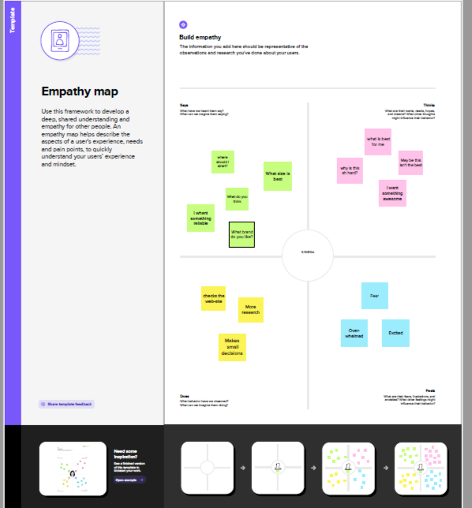

**2.2 BRAINSTORMING**

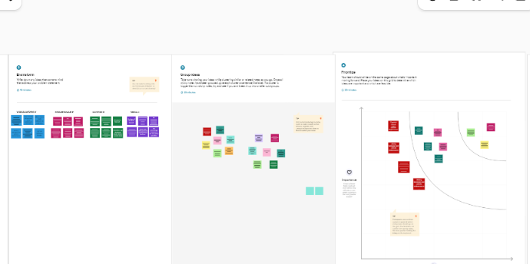

3**RESULT:**

3.1DATA MODEL:

|  |  |  |
| --- | --- | --- |
| S.No | **Field** | **Data Type** |
| Obj 1 | Driver Name | Text |
| Obj 2 | Licence | Text |
| Obj 3 | Mobile No | Number |
| Obj 4 | Fair Per Hour | Text |
| Obj 5 | Vehicle | Lookup(Vehicle) |

3.2 ACTIVITY & SCREENSHOT:

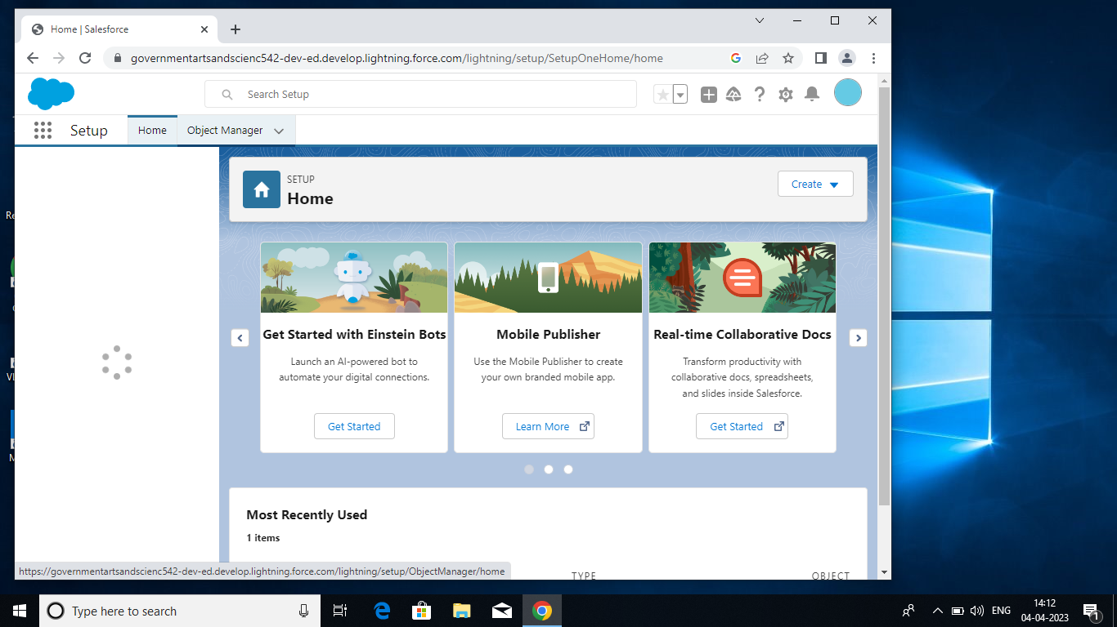

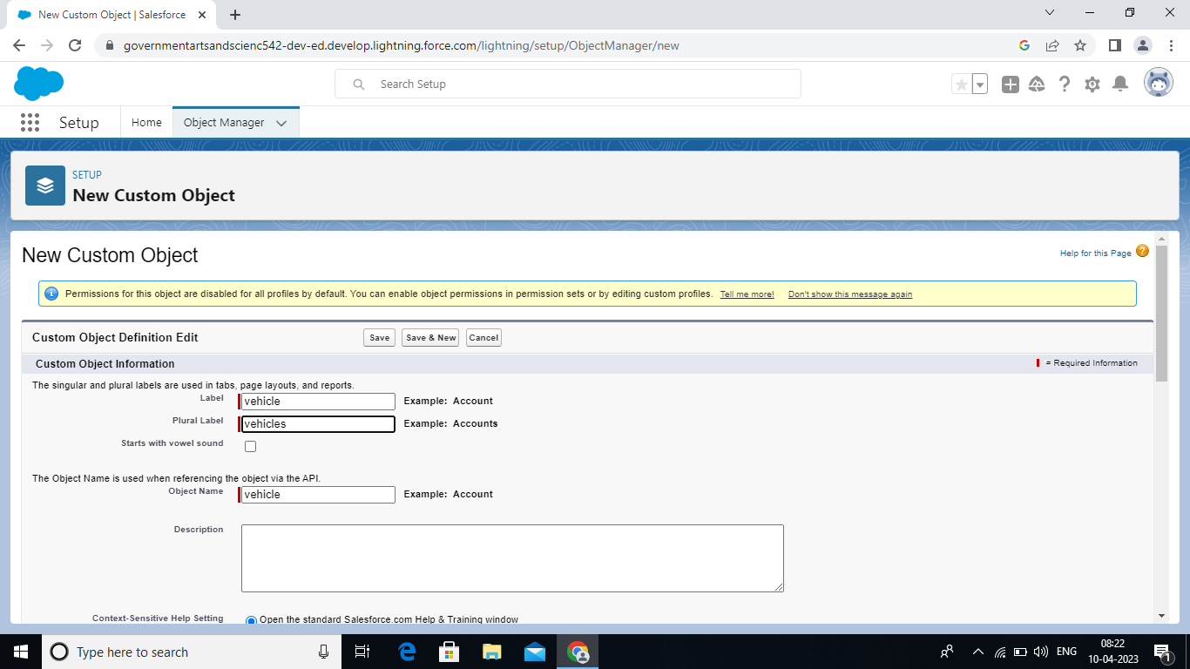

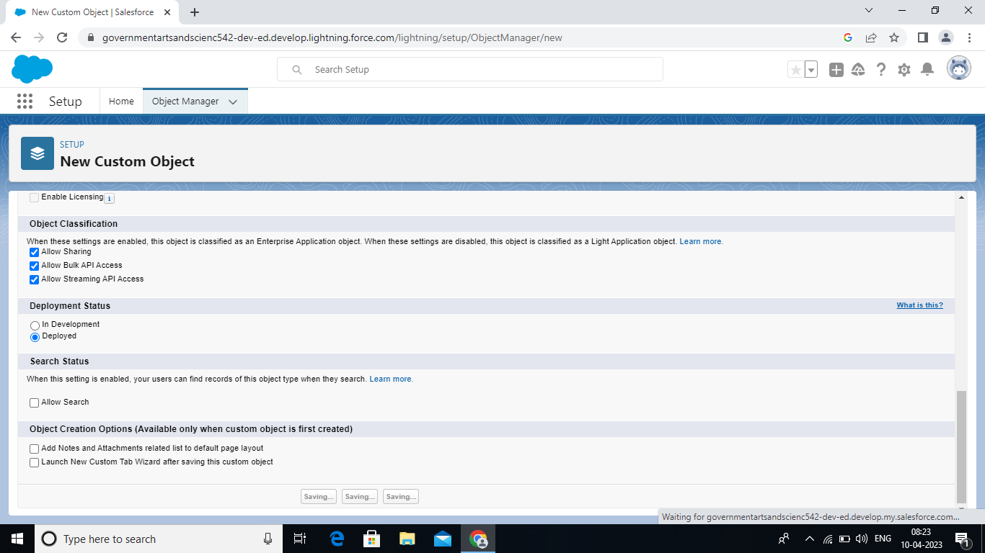

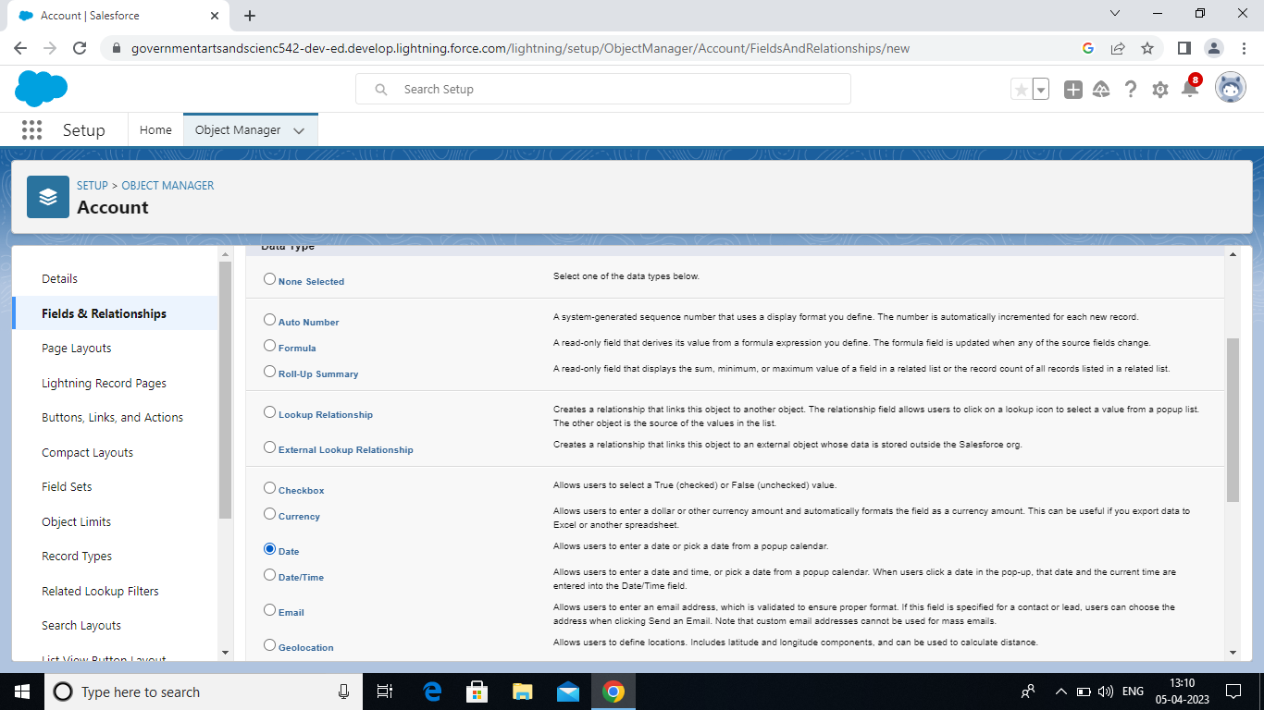

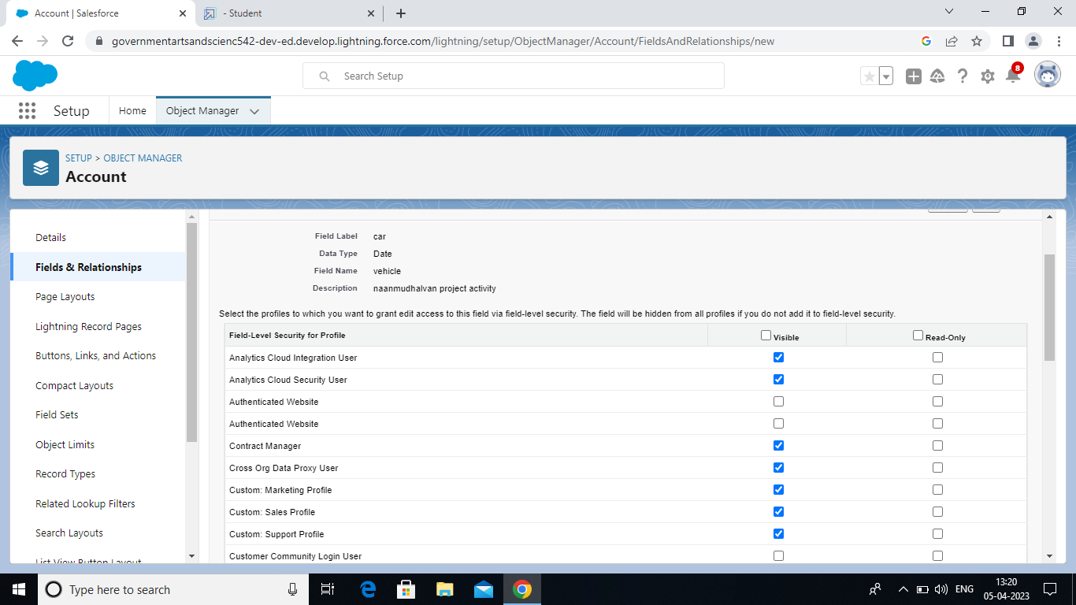

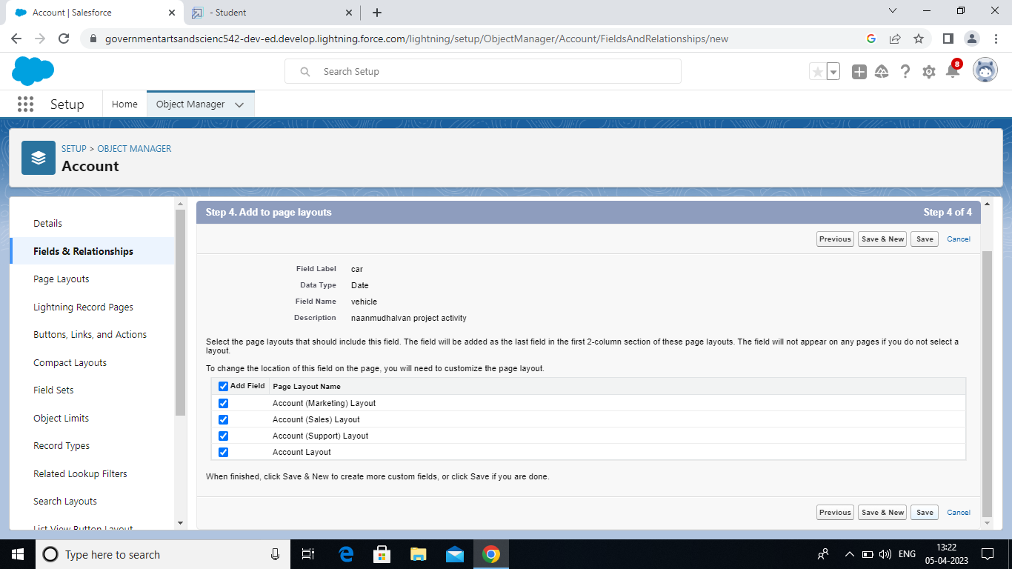

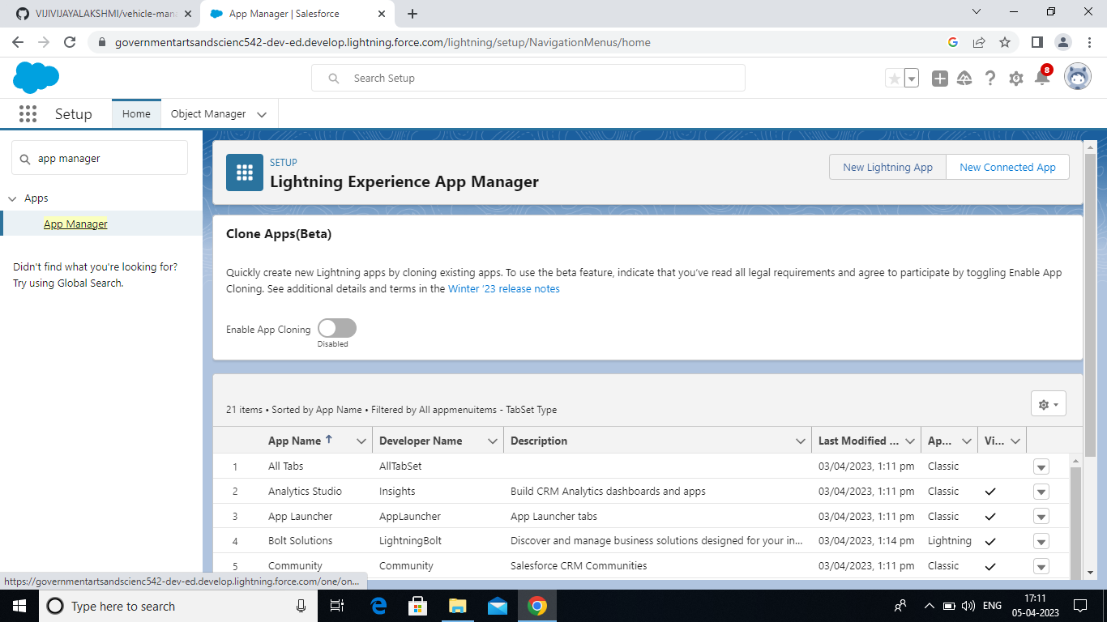

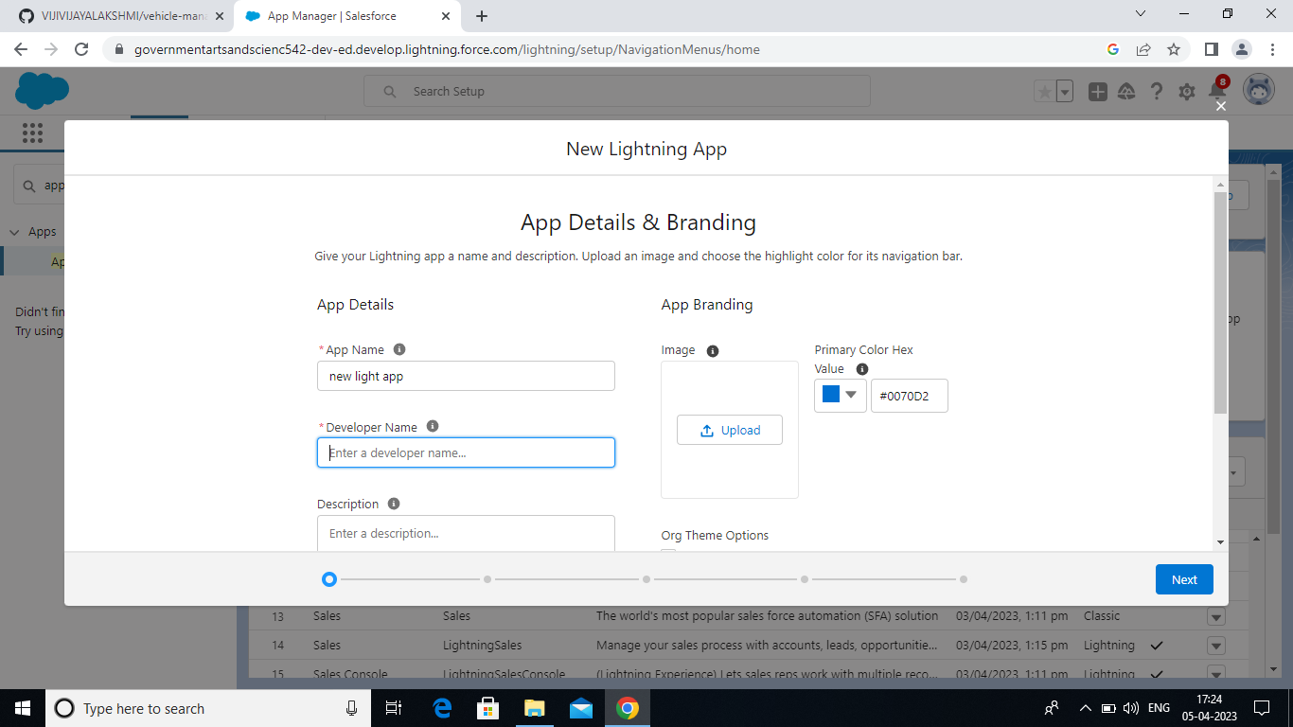

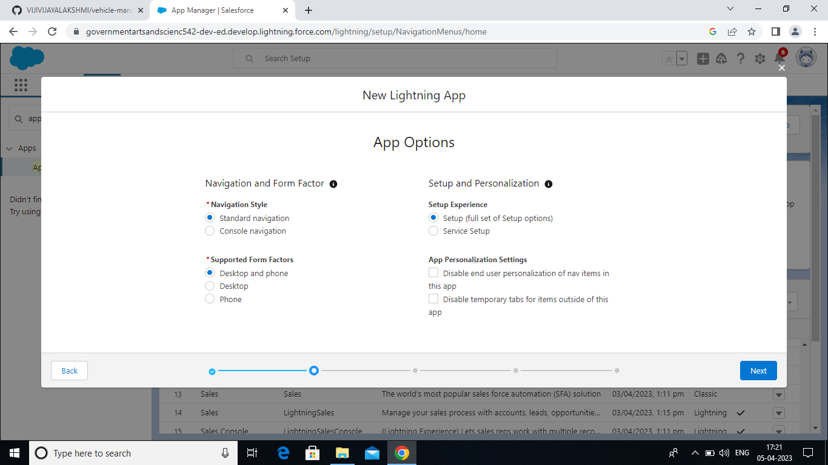

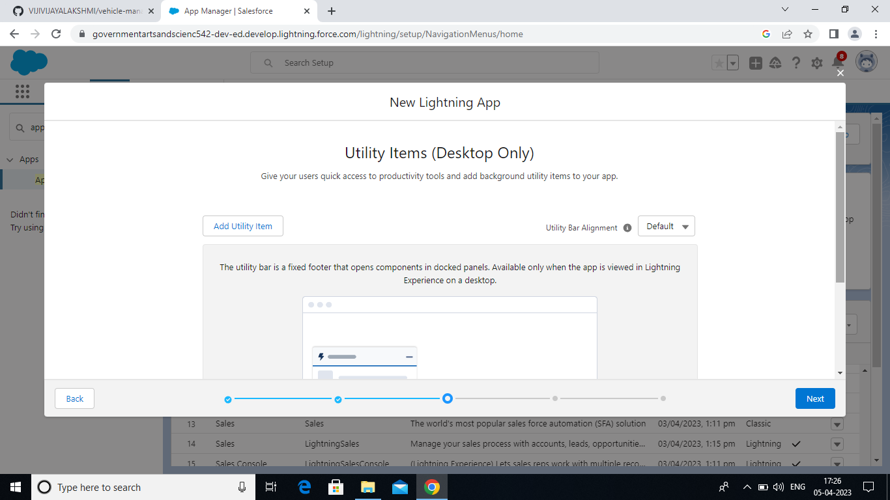

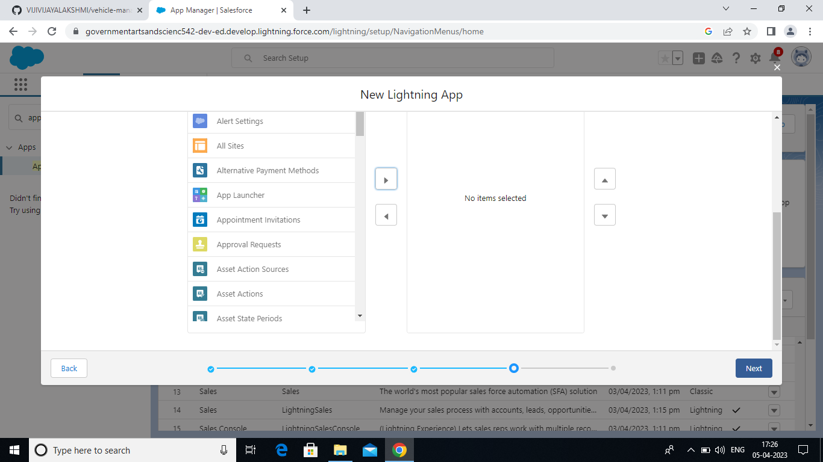

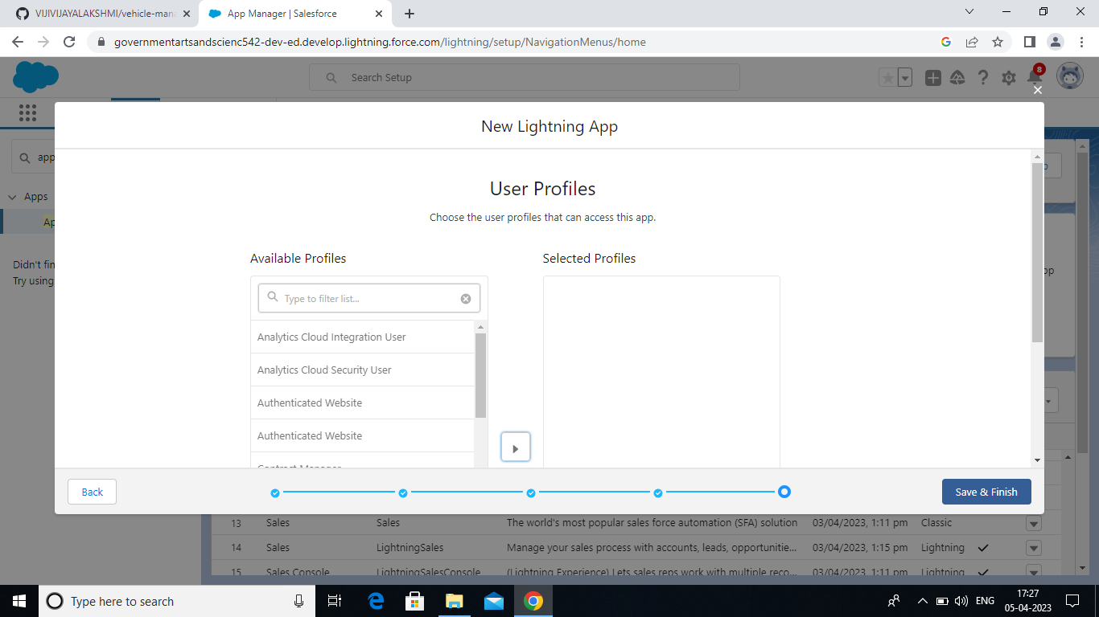

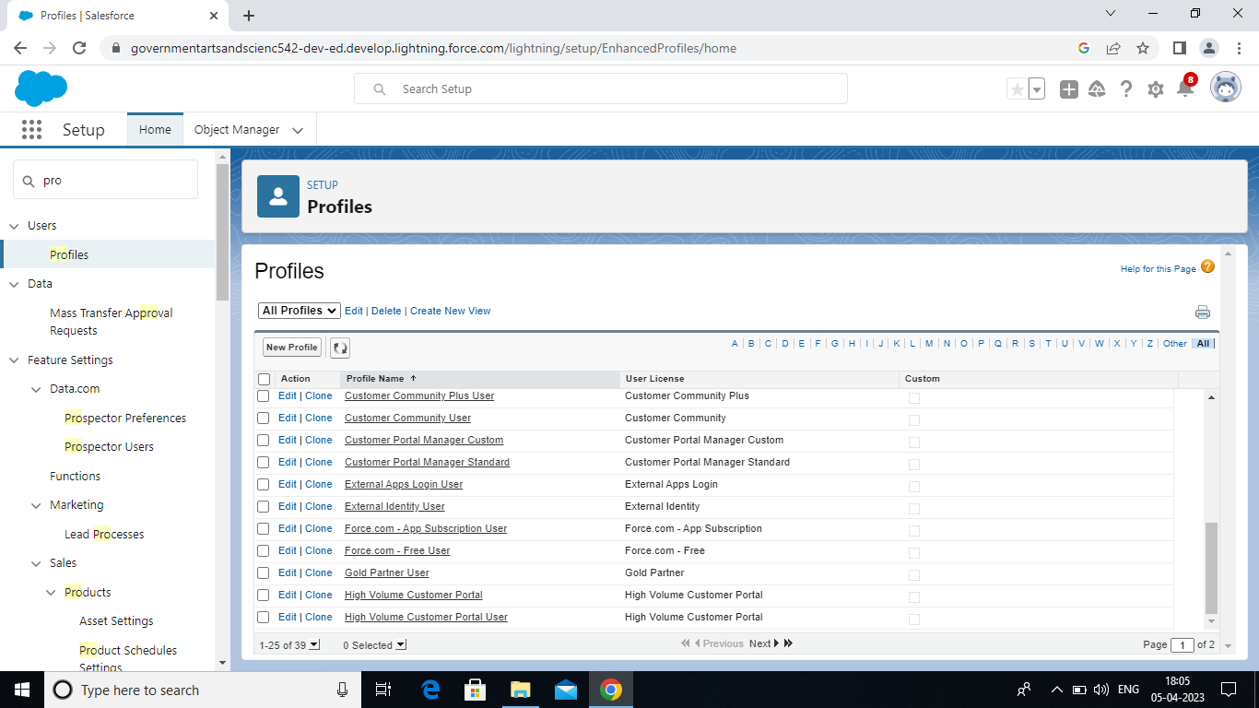

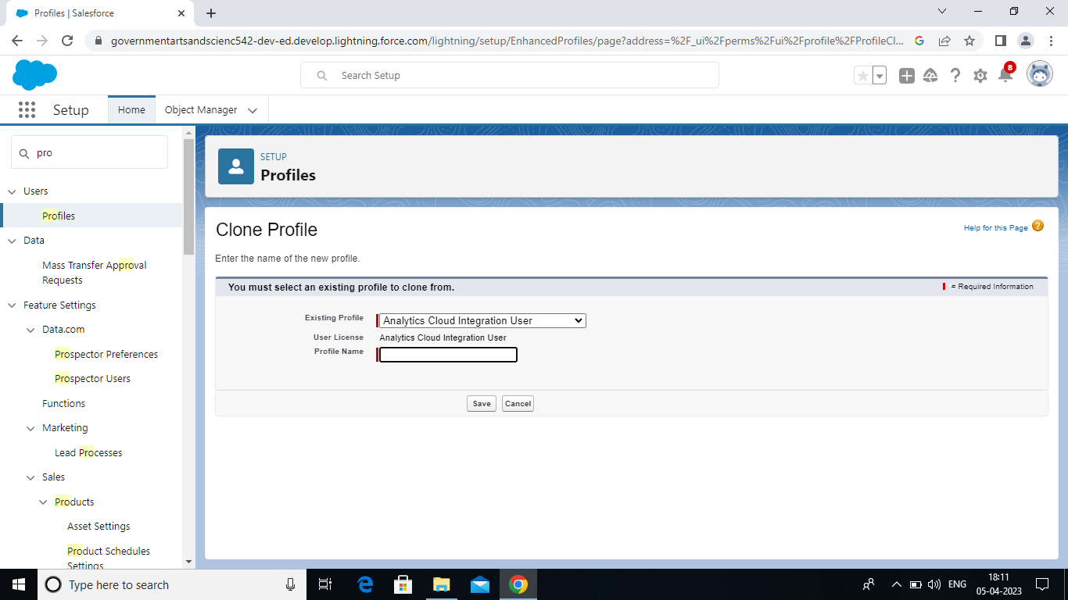

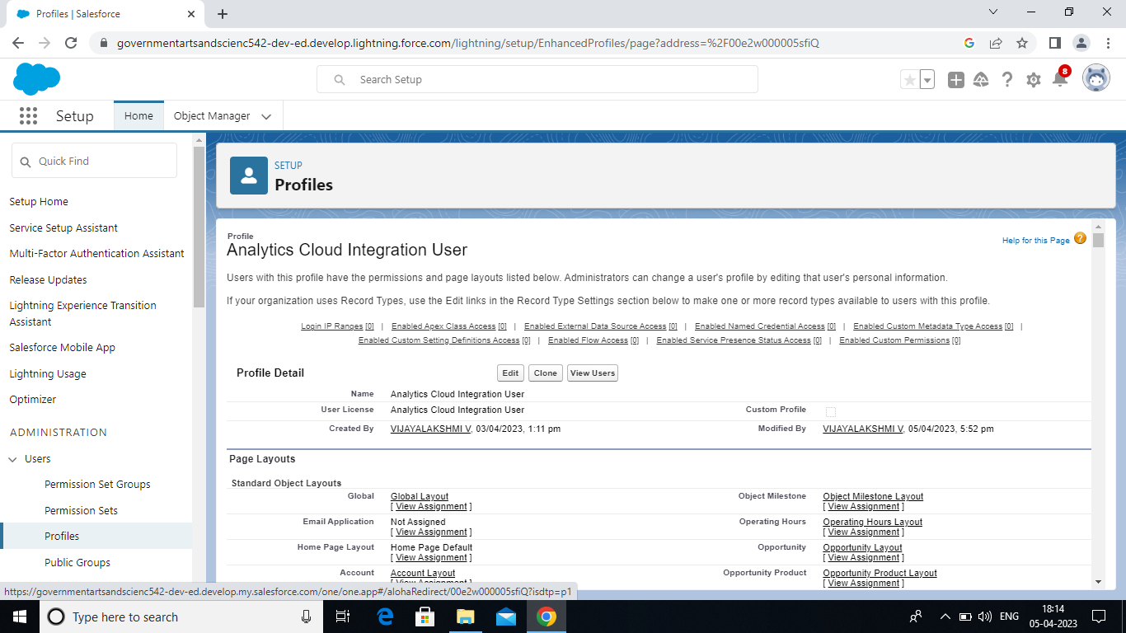

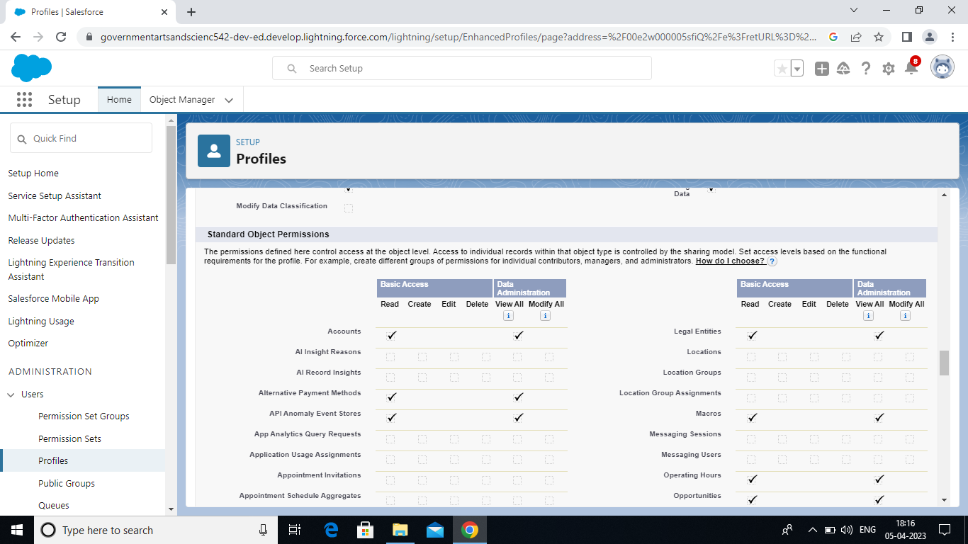

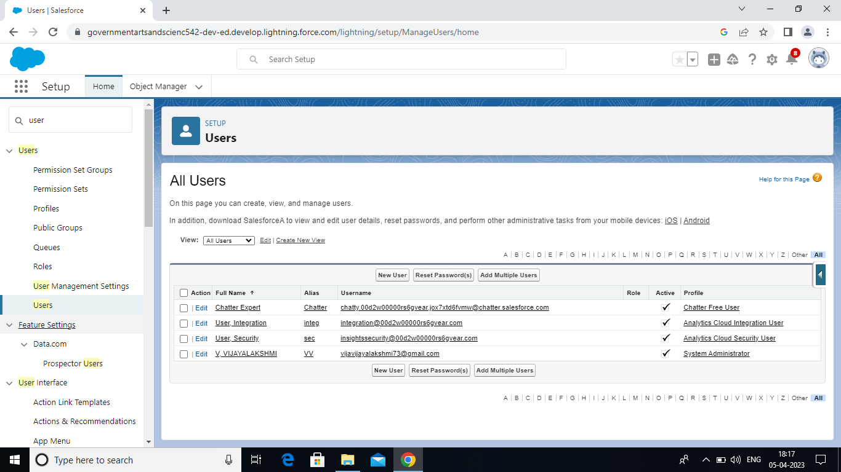

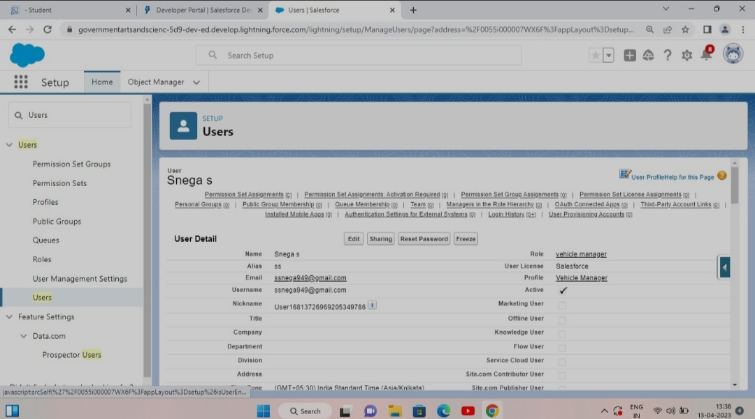

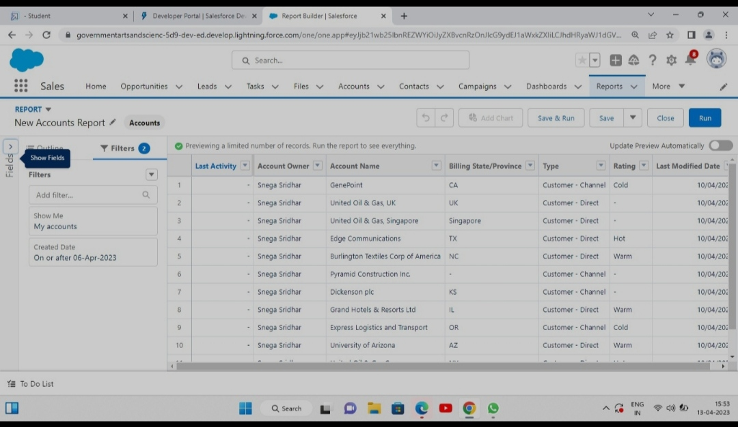

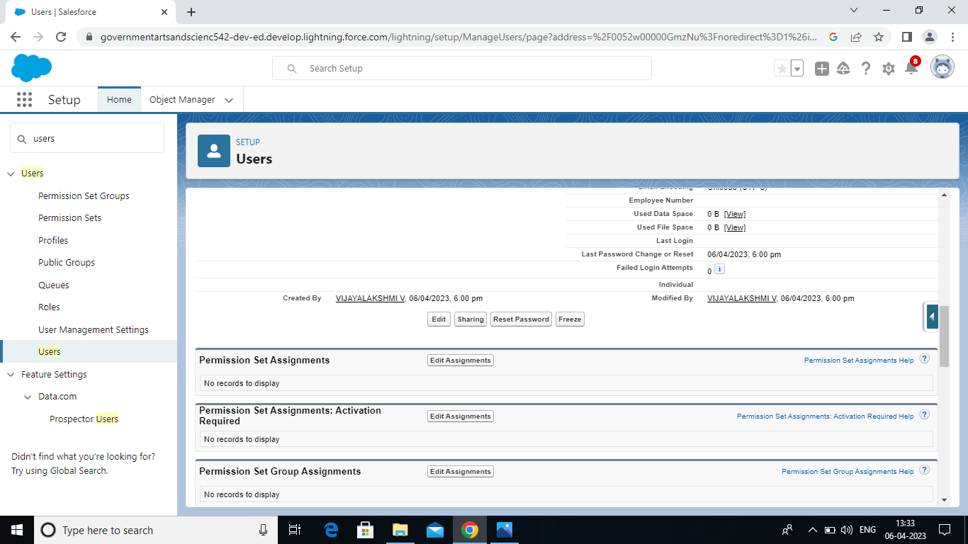

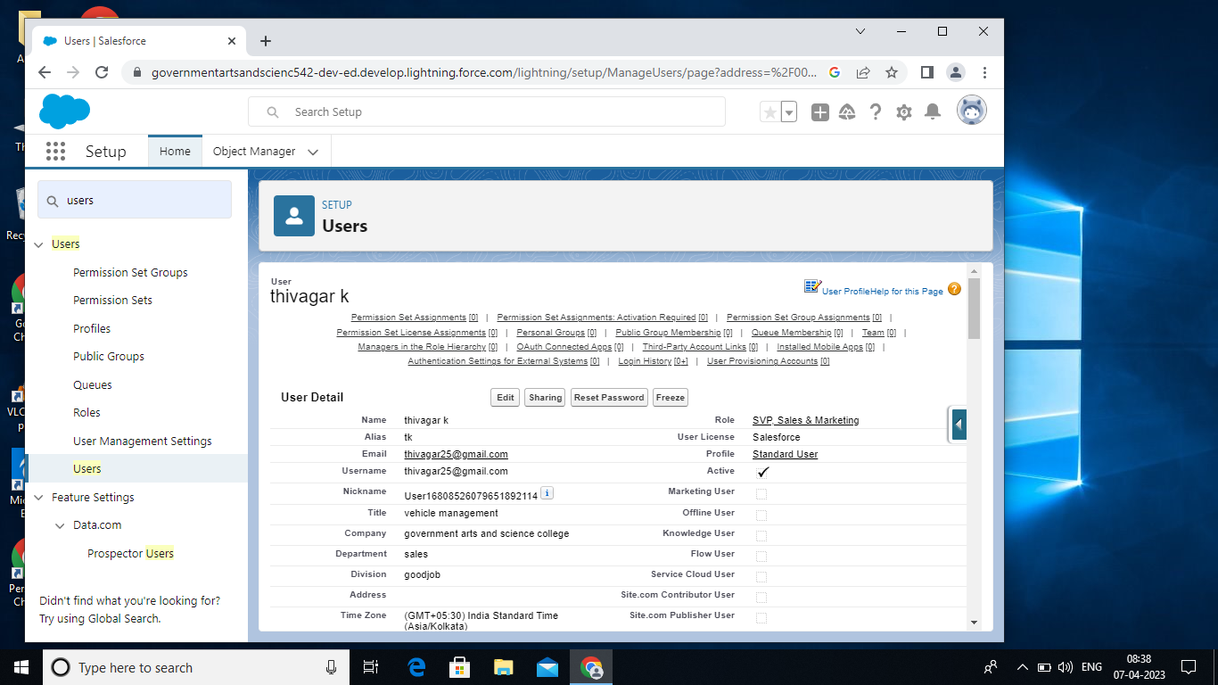

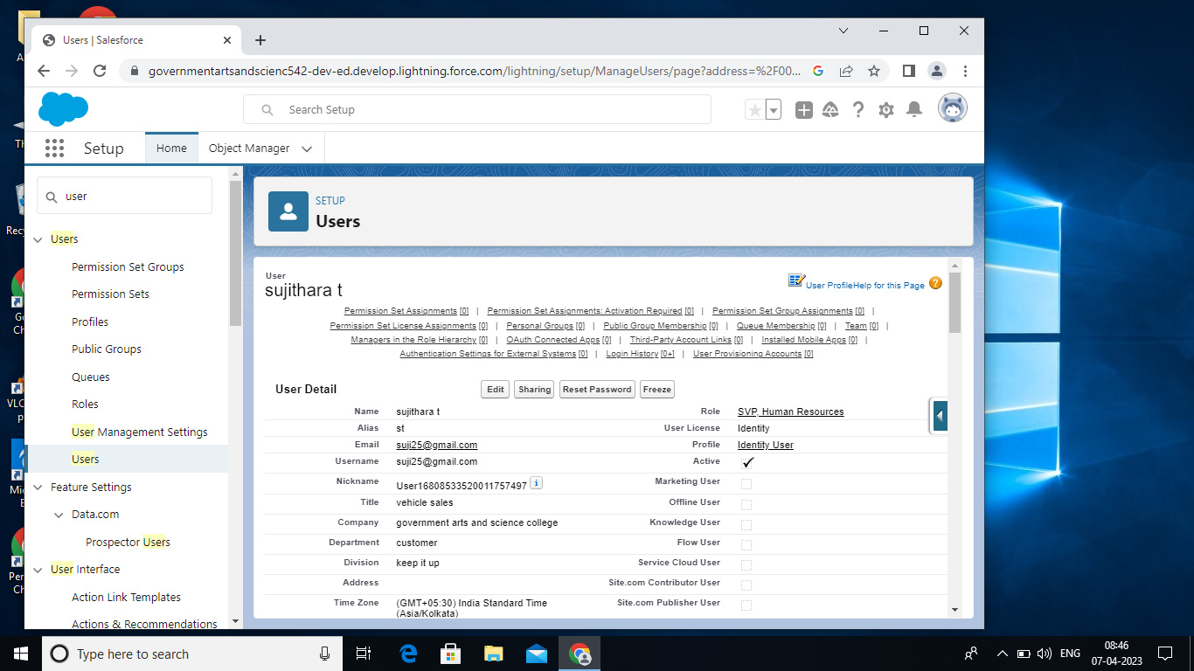

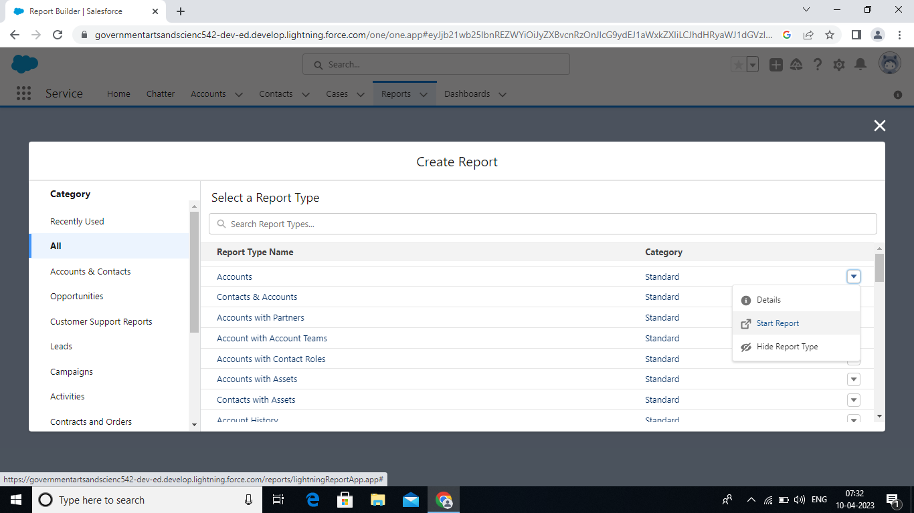

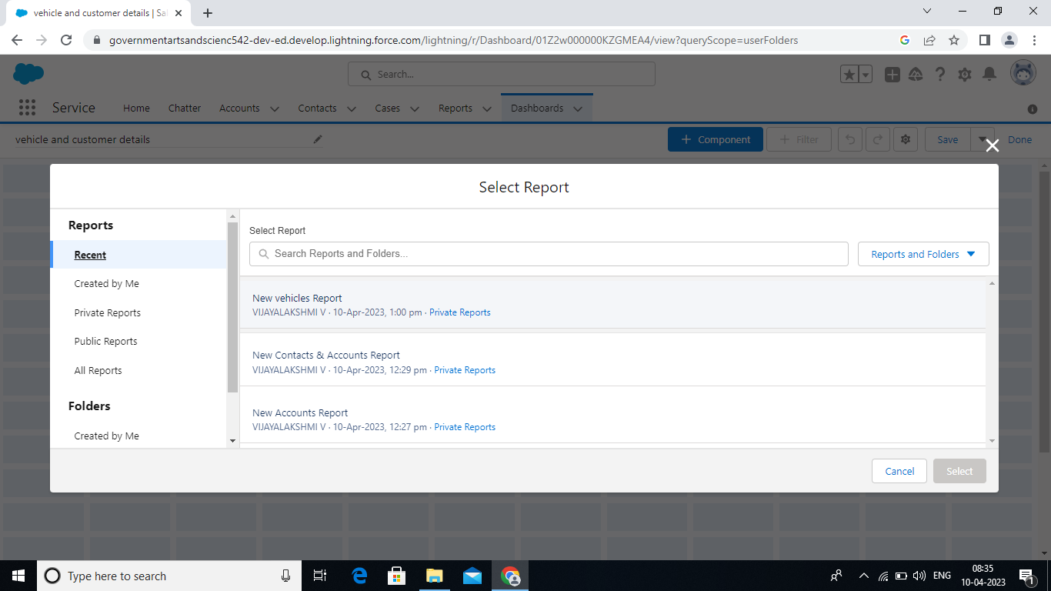

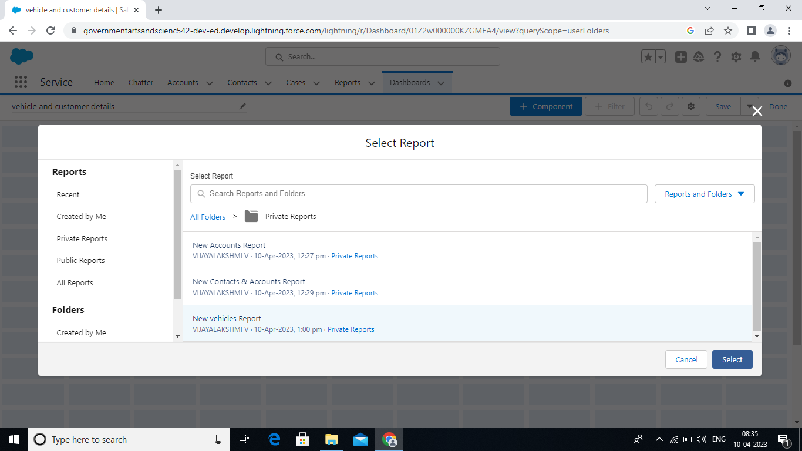

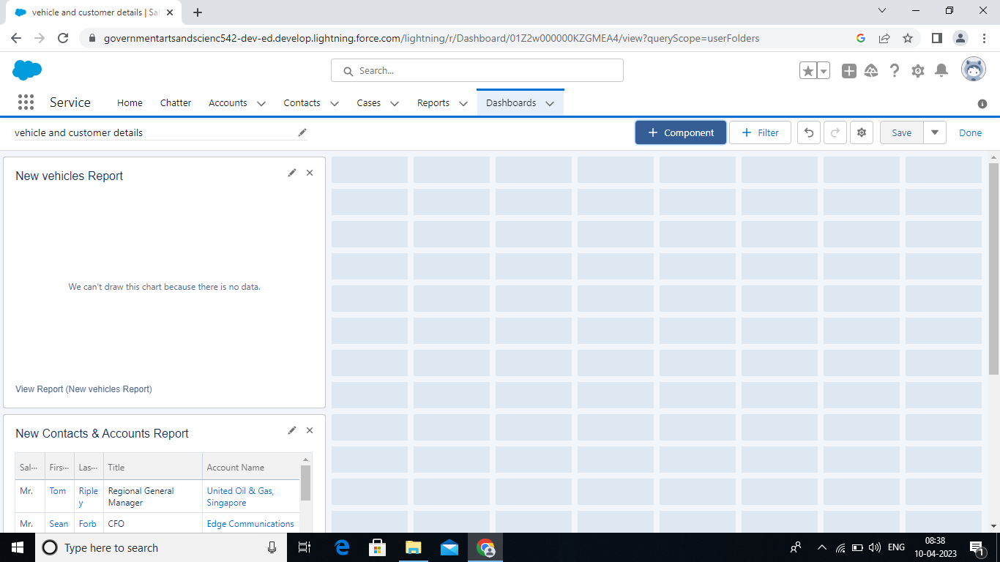

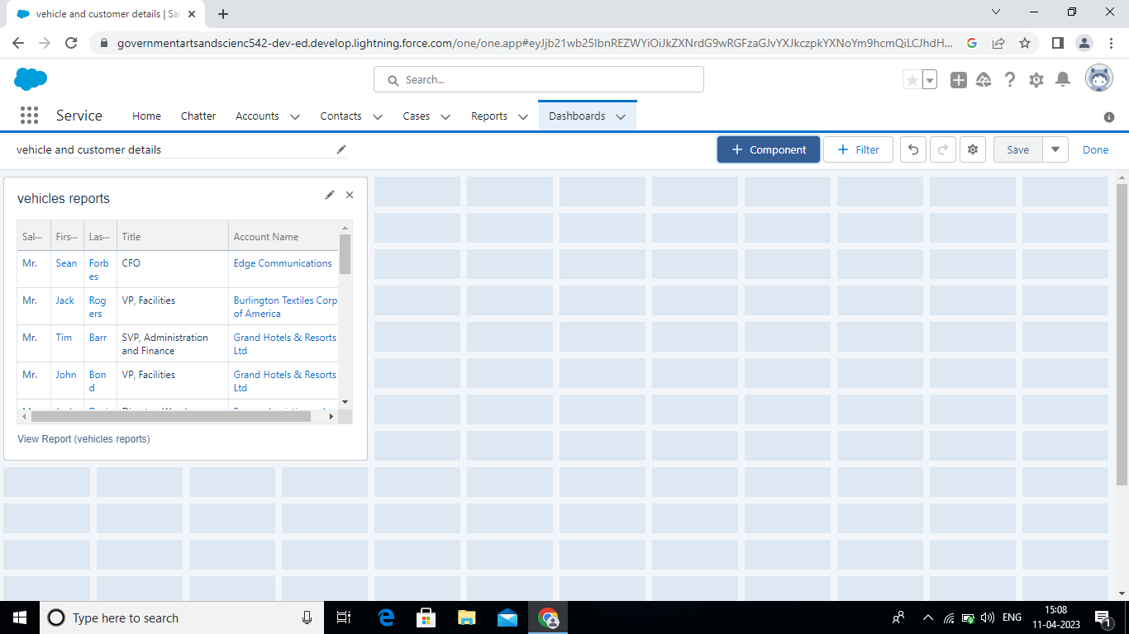

* **TRAILHEAD PROFILE PUBLIC URL**

**TEAM LEADER :** <https://trailblazer.me/id/ssridhar113>

**TEAM MEMBER: 1** <https://trailblazer.me/id/sowms33>

**TEAM MEMBER: 2** <https://trailblazer.me/id/tamik35>

**TEAM MEMBER: 3** <https://trailblazer.me/id/vijae5>

**TEAM MEMBER: 4** <https://trailblazer.me/id/selvi09>

**5 ADVANTAGES & DISADVANTAGES**

**Advantages**

* Improve fleet safety and working conditions.
* Improve the behavior and performance of drivers and beat unsafe driving.
* Schedule shifts and work hours.
* Leverage driver retention.
* Track vehicles, assets or professional equipment (even trailers and containers)
* Schedule routine maintenance.
* Manage fuel efficiency.

**Disadvantages**

It possesses a health risk to most children and can even lead to asthma. Carbon monoxide is formed by the combustion of fuels such as gasoline. It is both colourless and odourless gas. When carbon monoxide is inhaled, it can block the transport of oxygen to the brain, heart, and other important organs in the body.

* Air Pollution: Transportation is a major contributor to air pollution. ...
* Noise Pollution: Transportation traffic is a significant contributor to pollution. ...
* Congestion: Traffic congestion is a common problem in cities and densely populated areas.

**engines mean more fuel usage and not such great mileage** either. You might end up spending huge money on gas each month. Given how crowded our cities are these days, a big car may not be the best choice of ride. It takes up too much space and parking spots are hard to come by too

Noun **She had the disadvantage of growing up in a poor community.** They argued that the new regulations would place their company at a competitive disadvantage in the marketplace. There are advantages and disadvantages to the new system.

**APPLICATIONS:**

Use a Parking Management System Application and Park your Vehicle Smartly. A software application like the Smart Parking is the basic need of the present era.

Orchestrate your vehicles and assets management. Learn how you can digitize, organize and create amazing commands for your fleet management.

The **app** can show fleet managers who is driving which **vehicle**, digitise daily **vehicle** checks, and report damage or mechanical issues directly ...

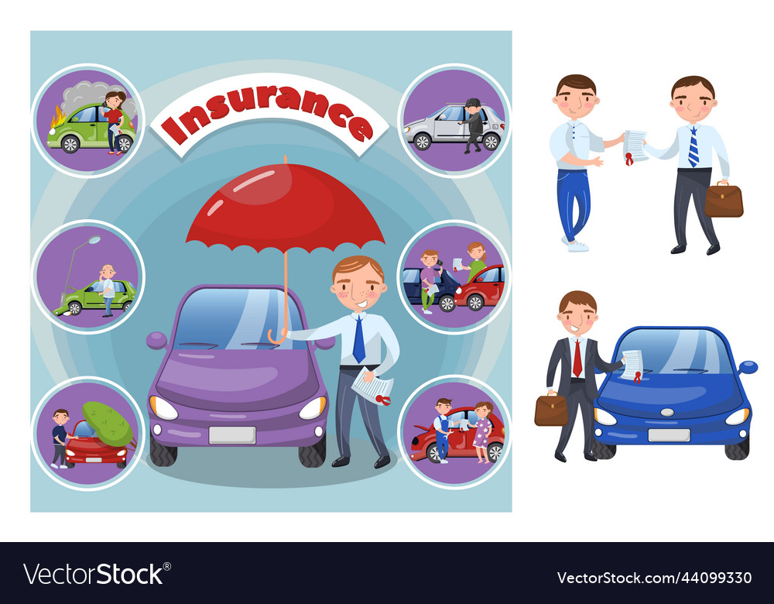

Fleet management solution refers to an application that helps businesses to coordinate and manage work vehicles in a central database for the smooth

suggested applying a Data Management System (DMS) for data storage in the intra-VAN. DMS only allows data exchange between a specific node which stores all

I built this Gym Managent Application for a clg mini project ... application which can be implemented in an Automobile Workshops or Vehicle Service Centers

The Vehicle Management System (VMS) is an application for the Automotive industry. It supports, in the area of Sales & Services, the business processes that you require as vehicle importer when dealing with your original equipment manufacturers (OEMs) and your dealers in new and used vehicle sales .

**CONCLUSION:**

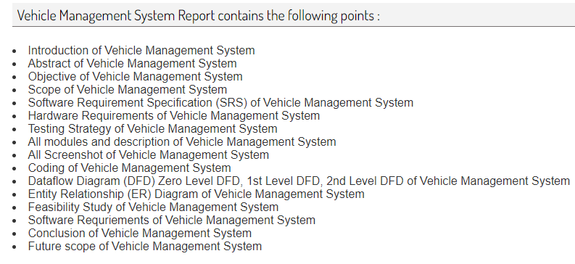

**FUTURE SCOPE:**

Software Requriements of Vehicle Management System; Conclusion of Vehicle Management System; Future scope of Vehicle Management System. Vehicle Management

To assist in the tracking of vehicles operation and the planning maintenance (i.e.: replacement of

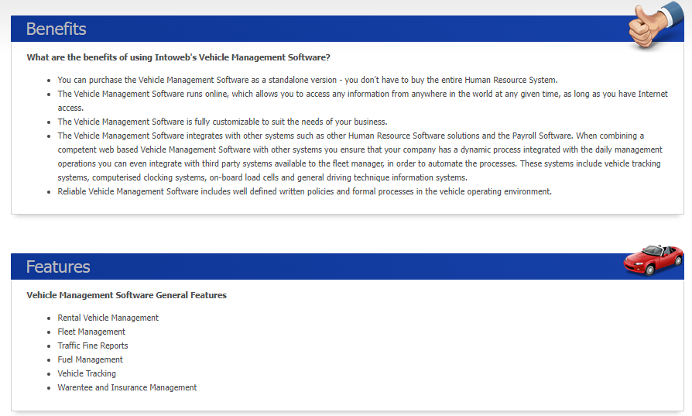

spare parts, etc.) that is important to avoid any damage/unexpected problem that might occur in the future that may cause hindrance to the operation and/or risking the safety of the drivers and passengers

The Vehicle Management System (VMS) is an application for the Automotive industry. It supports, in the area of Sales & Services, the business processes that you require as vehicle importer when dealing with your original equipment manufacturers (OEMs) and your dealers in new and used vehicle sales.

The main objective of the RTO Vehicle Registration System is to manage the details of Vehicle,Registration,Customer,Order,Vehicle Maker.

The Vehicle Management Software is a system providing management functions which allows companies to remove or minimize the risks associated with vehicles owned by the companies.